FAST LANE TRACKING USING HMM AND MHT FOR
AUTONOMOUS URBAN DRIVING

KeMAL kaplan
Department of Computer Engineering, Boğaziçi University
İstanbul,Turkey
Caner Kurtul
Department of Computer Engineering, Boğaziçi University
İstanbul,Turkey
H.Levent Akın
Department of Computer Engineering, Boğaziçi University
İstanbul,Turkey

Introduction
Lane tracking is one of the most important processes for autonomous vehicles because the navigable region usually stands between the lanes, especially in urban environments. Hough transform is one of the most popular algorithms for lane detection. In addition, a robust lane tracking method is required for reducing the effect of the noise and the required processing time. In this paper, we present a new lane tracking method which uses a partitioning technique for obtaining multiresolution Hough Transform (MHT) of the acquired vision data. After the detection process, for tracking the detected lanes, a Hidden Markov Model (HMM) based method is proposed. This work is a part of the ADES (Automatic Driver Evaluation System) Project in Artificial Intelligence Laboratory of Boğaziçi University.

Multiresolution Hough Transform
The classical Hough transform processes entire vision data in order to detect the lines. This scenario suffers from two main issues. First, the occluded lanes (i.e. another car passing through the lane) become noisy because the transformed relative intensity of the line decreases. Second, the relative intensity of the lines also decreases at the curves in the road. The proposed solution divides the road image into partitions, and the sizes of the partitions are inversely proportional to the distance of the partition to the vehicle.

After the image is partitioned, a few preprocessing steps are required before applying Hough transform. Since edge detection techniques are usually computationally expensive for real time applications, each partition is converted to binary images via applying a threshold filter after a color remapping process.

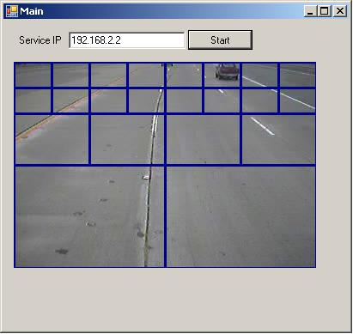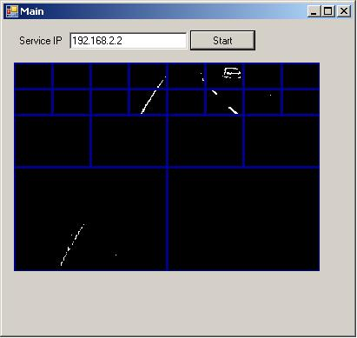
Figure 1. a) Partioned image, b) Binary image.

After the image is partitioned, a separate Hough transformation is applied to each single partition. The most intensive line in each partition, the candidate line segment, is taken into consideration in order to find the global lanes in the image. Since the Hough lines are represented in polar coordinates (r, θ) instead of rectangular coordinates (x, y), the candidate lines are grouped according to their slopes and distances to the center of the image as well as their intensities. Additionally, the center of the frame is the bottom point in our case.

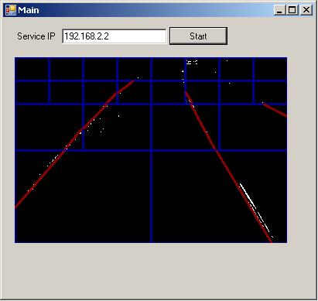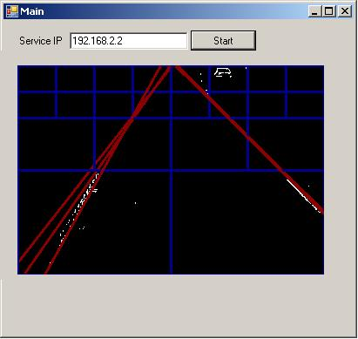
Figure 2. . a) Candidate lines, b) Transformed lines.

After the lines are grouped, the most intensive three clusters are assigned as the lanes. However, there may be less than three lanes if the sum of the intensities of the candidate lines is less than a threshold value.

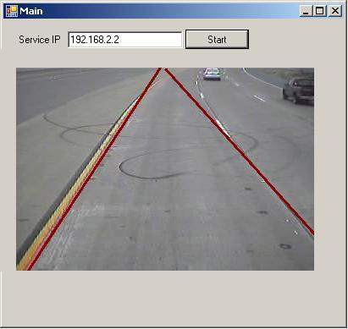
Figure 3. Detected lines.

Lane Tracking

For lane tracking, HMM is used to represent the relation between the current frame and its successor. As depicted below, each line in the current frame will is represented by an individual (r, θ) pair. In the next frame, the process will most probably observe the same line at (r', θ') location. The probability of observing (r, θ) pair in the next frame is devised as an HMM problem, and explained below.

r
θ
r'
θ'
Figure 4. a) Current frame (r, θ'), b) Next frame (r', θ )
The 2-D (r, θ) space is dissolved into two distinct spaces of r and θ respectively. The HMM formulation for θ is:

HMM states for θ are discretized as:
- (-90, -75, -60, -45, -30, -15, 0, 15, 30, 45, 60, 75, 90)

HMM observations for θ correspond to the candidate θ' values:
- (-90, -75, -60, -45, -30, -15, 0, 15, 30, 45, 60, 75, 90)

Emission probability matrix shows the probability of observing θ' in the next frame, having observed θ in the current frame. Since state spaces for θ and θ' are identical, it implies that emission probability matrix should be very similar to the transition probability matrix. Hence a similar one has been used, with an exception; the standard deviation is 2. Increasing the standard deviation has let us handle a wider range of state transitions with the trade-off of reduced performance.

Transition probability is Gaussian with Mean=0, Std.Dev=1.

Table 1. Transition probability matrix.

 | -90 | -75 | -60 | -45 | -30 | -15 | 0 | 15 | 30 | 45 | 60 | 75 | 90
-90 | 0.42 | 0.25 | 0.04 | 0 | 0 | 0 | 0 | 0 | 0 | 0 | 0 | 0.04 | 0.25
-75 | 0.25 | 0.42 | 0.25 | 0.04 | 0 | 0 | 0 | 0 | 0 | 0 | 0 | 0 | 0.04
-60 | 0.04 | 0.25 | 0.42 | 0.25 | 0.04 | 0 | 0 | 0 | 0 | 0 | 0 | 0 | 0
-45 | 0 | 0.04 | 0.25 | 0.42 | 0.25 | 0.04 | 0 | 0 | 0 | 0 | 0 | 0 | 0
-30 | 0 | 0 | 0.04 | 0.25 | 0.42 | 0.25 | 0.04 | 0 | 0 | 0 | 0 | 0 | 0
-15 | 0 | 0 | 0 | 0.04 | 0.25 | 0.42 | 0.25 | 0.04 | 0 | 0 | 0 | 0 | 0
0 | 0 | 0 | 0 | 0 | 0.04 | 0.25 | 0.42 | 0.25 | 0.04 | 0 | 0 | 0 | 0
15 | 0 | 0 | 0 | 0 | 0 | 0.04 | 0.25 | 0.42 | 0.25 | 0.04 | 0 | 0 | 0
30 | 0 | 0 | 0 | 0 | 0 | 0 | 0.04 | 0.25 | 0.42 | 0.25 | 0.04 | 0 | 0
45 | 0 | 0 | 0 | 0 | 0 | 0 | 0 | 0.04 | 0.25 | 0.42 | 0.25 | 0.04 | 0
60 | 0 | 0 | 0 | 0 | 0 | 0 | 0 | 0 | 0.04 | 0.25 | 0.42 | 0.25 | 0.04
75 | 0.04 | 0 | 0 | 0 | 0 | 0 | 0 | 0 | 0 | 0.04 | 0.25 | 0.42 | 0.25
90 | 0.25 | 0.04 | 0 | 0 | 0 | 0 | 0 | 0 | 0 | 0 | 0.04 | 0.25 | 0.42

Emission probability is Gaussian with Mean=0, Std.Dev=2.

Table 2. Emission probability matrix.
 | -90 | -75 | -60 | -45 | -30 | -15 | 0 | 15 | 30 | 45 | 60 | 75 | 90
-90 | 0.22 | 0.20 | 0.13 | 0.06 | 0 | 0 | 0 | 0 | 0 | 0 | 0.06 | 0.13 | 0.20
-75 | 0.20 | 0.22 | 0.20 | 0.13 | 0.060 | 0 | 0 | 0 | 0 | 0 | 0 | 0.06 | 0.13
-60 | 0.13 | 0.20 | 0.22 | 0.20 | 0.13 | 0.06 | 0 | 0 | 0 | 0 | 0 | 0 | 0.06
-45 | 0.06 | 0.13 | 0.20 | 0.22 | 0.20 | 0.13 | 0.06 | 0 | 0 | 0 | 0 | 0 | 0
-30 | 0 | 0.06 | 0.13 | 0.20 | 0.22 | 0.20 | 0.13 | 0.06 | 0 | 0 | 0 | 0 | 0
-15 | 0 | 0 | 0.06 | 0.13 | 0.20 | 0.22 | 0.20 | 0.13 | 0.06 | 0 | 0 | 0 | 0
0 | 0 | 0 | 0 | 0.06 | 0.13 | 0.20 | 0.22 | 0.20 | 0.13 | 0.06 | 0 | 0 | 0
15 | 0 | 0 | 0 | 0 | 0.06 | 0.13 | 0.20 | 0.22 | 0.20 | 0.13 | 0.06 | 0 | 0
30 | 0 | 0 | 0 | 0 | 0 | 0.06 | 0.13 | 0.20 | 0.22 | 0.20 | 0.13 | 0.06 | 0
45 | 0 | 0 | 0 | 0 | 0 | 0 | 0.06 | 0.13 | 0.20 | 0.22 | 0.20 | 0.13 | 0.06
60 | 0.06 | 0 | 0 | 0 | 0 | 0 | 0 | 0.06 | 0.13 | 0.20 | 0.22 | 0.20 | 0.13
75 | 0.13 | 0.06 | 0 | 0 | 0 | 0 | 0 | 0 | 0.06 | 0.13 | 0.20 | 0.22 | 0.20
90 | 0.20 | 0.13 | 0.06 | 0 | 0 | 0 | 0 | 0 | 0 | 0.06 | 0.13 | 0.20 | 0.22

Regarding the HMM formulation of r, it is evident that the strategy is similar to the θ case. Only difference is about the state and observation spaces. HMM states for r are discretized as:
- (20, 40, 60, 80, 100, 120…)
HMM observations for r correspond to the candidate r' values:
- (20, 40, 60, 80, 100, 120…)

Conclusion

Lane tracking is one of the major tasks in autonomous urban driving. A hybrid solution of MHT with HMM is applied in this work. So far, the solution yielded promising results. Since each successor frame is closely related to its predecessor, the transition and emission matrices of HMM are significantly sparse. The sparse nature simplifies the solution, which is crucial for realtime applications. Standard deviation of emission probability matrix has significant effect on the accuracy of the overall system. Further progress and final results will be included in the paper.
References
- Lawrence R. Rabiner, "A tutorial on Hidden Markov Models and selected applications in speech recognition". Proceedings of the IEEE 77 (1989).
- Ephraim Y, Merhav N, "Hidden Markov processes". IEEE Trans. Inform. Theory (2002).
- Duda, R. O. and P. E. Hart, "Use of the Hough Transformation to Detect Lines and Curves in Pictures," Comm. ACM, Vol. 15, pp. 11–15 (1972).
- He, Y., Wang, H. and Zhang, B., Color-based road detection in urban traffic scenes. IEEE Transactions on Intelligent Transportation Systems. v5 i4 (2003).
- J.C. McCall, M.M. Trivedi, An integrated, robust approach to lane marking detection and lane tracking, in: Proceedings of IEEE Intelligent Vehicles Symposium (2004).
- Yu, B. and Jain, A.K., Lane boundary detection using a multiresolution Hough transform, Image Processing (1997).

